Connecticut B.A.S.S. Federation Nation
Meeting Minutes
July 26, 2007

The regular monthly meeting of the Connecticut B.A.S.S. Federation Nation was called to order July 26, at 7:31 p.m. by the President.

Roll Call: The following clubs were absent: None. All clubs were present.

Excused Absences from the previous month: CT Valley Bassmasters, MidConn Anglers, Southern CT Bass Anglers, Tolcott Mountain Bassmasters, Wallingford Bassmasters.

The minutes of previous month’s minutes where accepted as posted.

Correspondence

The Federation Nation Online Roster system will be shutting down for upgrades the first two weeks of August.

Long time writer for B.A.S.S., Tim Tucker was killed in an auto accident recently. For complete story go to; http://sports.espn.go.com/outdoors/bassmaster/news/story?page=b_news_tim_tucker_7_16_07

Cabela’s has signed on with B.A.S.S. to sponsor Casting Kids.
http://sports.espn.go.com/outdoors/bassmaster/youth/news/story?page=b_youth_Cabela's_sponsorship

Scam – There is a potential scam concerning B.A.S.S. Renewals. If you are contacted by anyone other then B.A.S.S. about your membership renewal, please let us and B.A.S.S. know.

Lowrance – has been bought out. Anyone from the current or past State Teams that placed orders and that are having problems with Lowrance should contact Bob.

Bud Morin, long time CBFN member, left for a job opportunity out of state. He had paid for all four trail events at the beginning of the year. He was able to fish the first event before he left. He has donated the remaining fees to the CBFN. $50.00 to tournament trail, $50.00 to Youth and $50.00 to scholarship.

Reports of Officers

Treasurer’s Report:

As of June 30, 2007 there were the following amounts in the accounts:

CBFN General Checking - $19,955.86

CBFN Money Market Account - $11,531.43

CBFN Scholarship Checking - $2,779.52

CBFN Scholarship Money Market Account - $8,856.84

Scholarship Report: Sylvia Morris

Working on forming the new committee for next year.

The Scholarship Tournament is scheduled for Saturday, October 27, 2007.

Conservation / Environmental Report: David Santos

Invasive Species

- Water chestnuts on the CT River - The CT DEP would like your help in collecting and monitoring the spread of this EXTREMELY INVASIVE AND HARMFUL PLANT. If you see what you think is chestnut, try and collect it from the river, note the GPS location (if possible) and call the DEP at (860) 424-3034. For more information check out http://www.audubon-mas.org/pages/fwchstnt.htm

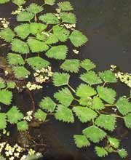
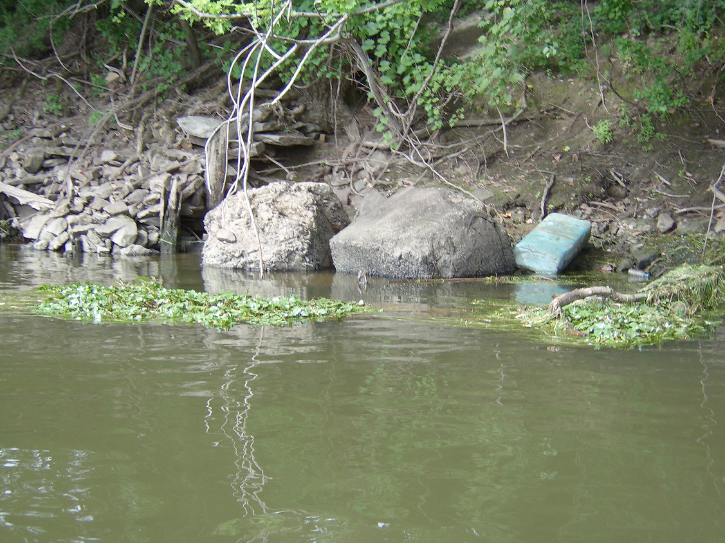



- An invasive algae known as didymo has made its way into the Connecticut River in Vermont and New Hampshire, and its creeping south. Hyatt says didymo, or Didymosphenia geminata, is native to Northern Europe, but it's been spreading over the last ten years. "Typically it only likes cold clear water but for some reason it's spreading to other places," he said. Environmentalists say that this algae will eventually get to Connecticut, but large bodies of water, like the Connecticut River, aren't the biggest concern. The D.E.P. worries about it being transported from the river into smaller streams and lakes, where it can do the most harm. The only way to prevent it from spreading is for boaters and anglers to check, clean and dry their boats, weighters and all fishing equipment. It only takes a small amount of this algae to cause big problems.

Berkley Conservation Institute – We will be collecting UPC codes from Berkley lines. We need 75 to get a free Fish Hab.

Fish Care – Now that we are in the dog days of summer, remember to keep fish in your livewell properly aerated and the water cooled. Keep ice in water bottles to keep water temps cool and livewell treatment like rejuvenade.

Gardner Lake Boat Launch - The launch will close immediately after Labor Day. They expect that the launch will be closed until the spring and open sometime in May. There is a possibility that the launch may be open by Opening Day, however, for that to occur, we will need an early & warm spring. Apparently bituminous plants typically close by late fall/early winter, and paving occurs late in the renovation process, paving may not occur until spring.

Youth Committee: Terry Baksay

No report

Tournament Committee: Alan D. Guite

We had our third tournament of the 2007 season on the Connecticut River out of Haddam Meadows State Park on July 8th. Our new fish care system was used for the first time at this event and all went well. We received positive feedback from Bill Foreman of the D.E.P. Inland Fisheries and Alex Sokolow from D.E.P. Law Enforcement. I’d like to thank the tournament committee for all their efforts and especially Dave Santos for obtaining the grant which allowed us to purchase the new system. The positive image that this will create for us in the future will be extremely beneficial to our organization. The more professional we look in the eyes of the D.E.P. and the general public will in turn allow us to obtain special privileges in the future. Thanks again to everyone who participated and helped run this event.

Our next scheduled event, the Bryan V. Kerchal Tournament of Club Champions, better known as Mr. Bass, will be held on Saturday, August 4, 2007. A pairings meeting is scheduled for Tuesday, July 31, 2007. I want to remind everyone that this tournament consists of each clubs Angler of the Year from the 2006 season. Please note: If your club did not exist within the CBFN in 2006 your club will not be eligible to participate until 2008.

We have three clubs that have been found to be in poor standing with the Connecticut Bass Federation Nation due to bylaw violations in regards to absenteeism. These clubs will not be allowed to participate in the Bryan V. Kerchal Tournament of Club Champions or the CBFN Two Day State Championship.

CBFN Tournament #4 is scheduled for Sunday, August 12, 2007 at Candlewood Lake Squantz State Park. We will be using both the Squantz and Lattins Cove launches for this tournament and once again will attempt to have only individuals who are paired launch from Lattins Cove.

Please keep in mind that all tournament agenda’s are now posted on the web site the week prior to each event. Please encourage your club members to read the agendas prior to the day of the event.

The tournament committee is always in need of help. If anyone is interested please contact myself or Sylvia Morris.

Proposed dates for the 2008 CBFN Tournament Trail are as follows:

Tournament 1 – Sunday, May 18, 2008
Tournament 2 – Sunday, June 15, 2008
Tournament 3 – Sunday, July 20, 2008
Tournament 4 – Sunday, August 17, 2008

Bryan V. Kerchal Tournament of Club Champions (Mr. Bass) – Saturday, August 2, 2008

C.B.F.N. Two Day State Championship – Saturday & Sunday, September 13 & 14, 2008

C.B.F.N. Classic – Saturday, October 4, 2008

Fishing Advisory Report: David Santos
None

Boating Advisory Report:

It has been reported by many anglers that ENCON Police are working the Rocky Hill area of the CT. River heavily and are issuing tickets for the slightest violations.

State Team Report: Paul Carter

Working on jackets and shirts.

Raffle Report:
If you have signed up new members since the tickets where handed out in March, please contact Armond for their tickets. New members are obligated to sell tickets unless they joined less than 90 days from the Raffle Date. The Raffle date is September 25, 2007. Anyone signed up between March and June 28 is required to sell tickets. It is the Club’s responsibility to get these tickets. There are over $1800.00 in ticket sales due because of new members that signed up after the tickets where handed out. (By Laws Rule 11.)

Financial Committee: Ray Bessette
No report

Audit Committee: Lewis Schaller

The Audit of 2006 Financials were found to be in good order and all records properly kept. A few items noted to be addressed by CPA Auditor, I.E. Sales tax and board member expenses on the 990 form

Review of board expenses noted a drastic drop in out of pocket expenses being submitted. Suggestion was made to close youth checking account and merge it into the general checking account. Review of State team expenses completed and questions clarified on amounts being spent during the meeting.

Banquet Committee: Sylvia Morris
None

Membership Committee:
None

Sponsors Committee: Ed Weeks
None

All Reports approved as given.

Old Business

None

New Business

Nominations for Tournament Director are due. One nomination received; Alan Guite. Elections are due at the August meeting.

A motion was made to donate $250.00 to the Tim Tucker fund on behalf of the CBFN. Motion Adopted.

It was announced that Jack would be leaving for an overseas assignment within his company for the next year. He will be leaving in the next 30 to 60 days. His wife, Jamie has volunteered to fill in for him as Secretary. Motion was made to allow Jamie to assume the job of Secretary in Jack’s absence. This Motion was Adopted.

Announcements

Bryan Kerchal Camp – There will be a kids camp in 2007. Point of contact is Jennifer Sposta, 203-426-3624. The camp will be August 13 – 17 and Boat Captains are needed.

CBFN Scholarship Tournament – October 27, 2007

Next Meeting: August 23, 2007

Meeting was adjourned at 8:46 pm

Jack Vinyard
CBFN Secretary

