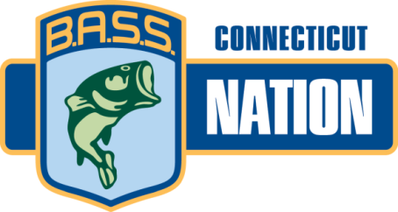

CONNECTICUT B.A.S.S NATION
Affiliate National B.A.S.S. Nation
Sponsored by:

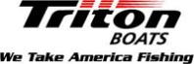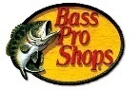

BY-LAWS

REVISED AS OF February 23rd, 2017
Package includes 2017 By-Laws, Standing Rules, Tournament Rules

