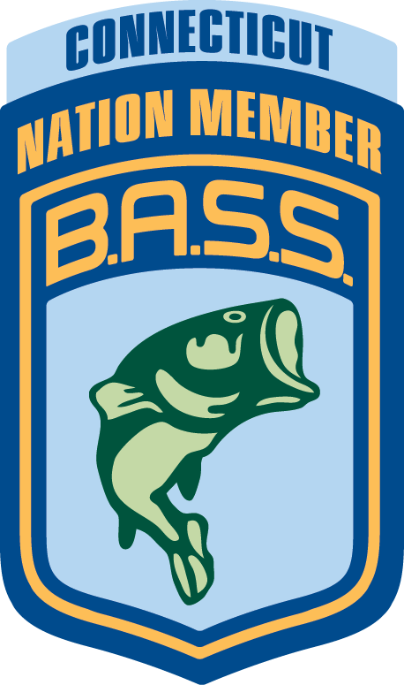
2019 CBN STATE CHAMPIONSHIP

TWO DAY


Sponsored by:
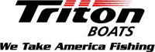
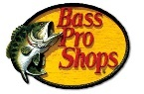
Sat., 10-5-2019 and Sun., 10-6-2019 7AM-3PM, Candlewood, Squantz (If over 50 boats, Latins will be used also and the Start time will be 8:00)

ANGLERS Entry Fee $150.00 (MUST HAVE A LINK IN ORDER TO FISH))
NAME ________________________________ CBN CLUB________________________________
ADDRESS_________________________________________________________________________
HOME PHONE____________________________ CELL PHONE _________________________
BOAT______________________________ SIZE __________ MOTOR H.P. RATING________
BOAT REGISTRATION NUMBER ___________________________ STATE __________
I have read and understand the Connecticut B.A.S.S. Nation Tournament Rules & Regulations. I agree to abide by them during the tournament. Enclosed is a copy of my current boat insurance policy ($300,000 minimum liability) and a copy of my CT Boating Certificate. If a substitute boat is to be used, contact the Tournament Director prior to the Tournament. Boat Info, permission & insurance coverage is required.
Signature: ____________________________________________________ Date: _______________________

Both portions must be filled out, signed, a check /checks included, and mailed all together in one envelope

LINKED CO-ANGLER ENTRY FEE $100.00

NAME ________________________________CBN CLUB_________________________________
ADDRESS_________________________________________________________________________
HOME PHONE____________________________ CELL PHONE ________________________
I have read and understand the Connecticut B.A.S.S. Nation Two Day tournament rules & Regulations. I agree to abide by them during the Tournament.
Signature: ________________________________________ Date: ________________________________________

Complete both sections of application. Mail Entry Fees. (Checks payable to “CBN”) & copies of other applicable information to: CBN /co Vinny Mucci, 52 Chapel Hill Rd, North Haven, CT. 06473 Phone: 203-525-4105
must be POSTMARKED by Saturday Sept 21st, 2019 or Hand Delivered NO EXCEPTIONS.

If on Candlewood then ALL Anglers and ALL Co-Anglers must include a signed copy of the Zebra Mussel Cover letter with this application. Applications received without the applicable paperwork WILL BE RETURNED!

