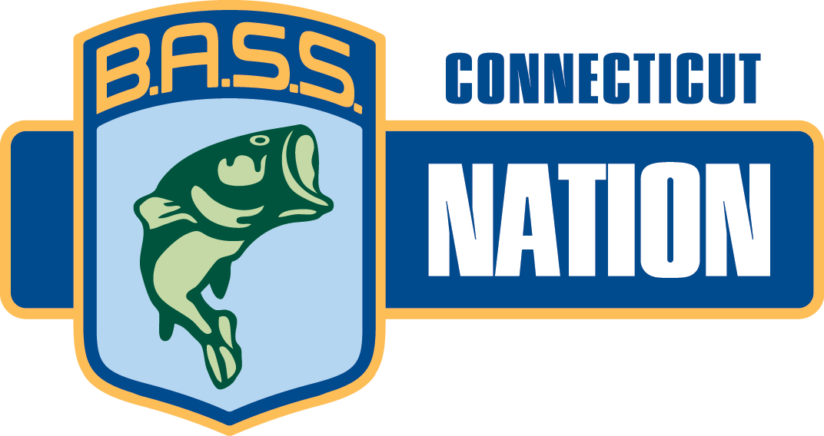
Connecticut B.A.S.S.
Nation, Inc.
Affiliate National B.A.S.S Nation

2024

Dear Potential Sponsor,

The Connecticut BASS Nation, Inc. (CBN) is having its annual Awards Banquet on Saturday, November 16th, 2024

We are a non-profit organization founded in 1974 with approximately 275 members. Presently there are 16 clubs comprised of men, women and children who take an interest in fishing and protecting our freshwater resources.

We encourage and promote “Catch and Release” fishing and are dedicated to educating our youth and conserving the environment. Each year the CBN awards scholarships to our angler’s family members to help defray the rising costs of college tuition.

We are looking for items to raffle at our awards banquet and would appreciate anything you can do to help us. 25% of all monies made from this raffle go into the High School account & Scholarship Account and the remainder offsets the cost of the banquet. In return, we will be happy to hang your Banner (if you have one) at the Banquet, or promote your company and/or product on our website CTBass.com

Please feel free to contact me at 203-877-0280 or email me at wefish2@att.net. Any donations can be sent to my attention at 35 Orient Avenue, Milford, CT 06460.

We appreciate and thank you for your consideration.

Sincerely,

Sylvia J. Morris, Banquet Chairperson

