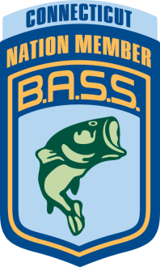 Connecticut B.A.S.S. Nation, Inc.
Affiliate National B.A.S.S. Nation

CBN 2014 Awards Banquet

Saturday, November 22, 2014

U.S.S. Chowder Pot IV

165 Brainard Road

Hartford, CT 06114

860-244-3311

Directions at www.chowderpot.com

Time: 5:30pm to 6:15 pm Appetizers
7pm – Dinner

Cost: $35 per person / $60 per couple – pay at the door

Reservations are required!

For reservations: Call Sylvia Morris – 203-877-0280

You may reserve seats by your club and we will reserve tables in the club’s name.
Clubs will be responsible to pay for the total number of seats reserved.
Deadline for Reservations is November 16th, 2014

Joe Horvath & Tom Reynolds will be Speakers

There will be Annual Awards, Women’s prizes and great raffle prizes!!!

MENU

Appetizers

A Buffet of Roast Sirloin of Beef - Italian Chicken w/ Scalloped Potatoes
Baked Stuffed Scrod – Broiled Salmon with Chili Glaze
Penne Marinara & Penne Vodka Sauce
Chef’s Choice of Vegetable, Warm Bread & butter
Chocolate Layer Cake or Strawberry Cheesecake
Coffee, Tea & Sodas

