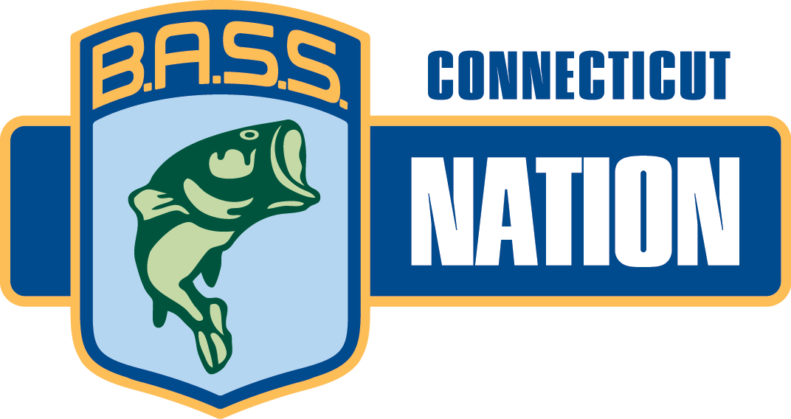
Connecticut B.A.S.S. Nation, Inc.
Affiliate National B.A.S.S. Nation

CBN 2024 Awards Banquet

Saturday, November 16th, 2024

Violis II at Wallingford Country Club
195 Long Hill Road
Wallingford, CT 06492
203-269-9320
Directions at: https://wallingfordcc.com/

Time: 5:00 pm to 6:00 pm Appetizers
Cheese, Crackers, & Vegetables

6:30– Dinner
BUFFET MENU

Mixed Greens Salad and Antipasto

Pasta Marinara & Vodka Cream

Prime Rib Carving Station, Chicken Piccata, Baked Scrod

String Beans & Oven Roasted Potatoes

Rolls & Butter
Desserts
Coffee, Tea & Sodas

Cost: $55.00 a person – pay at the door

Reservations are required!

For reservations: Call Sylvia Morris – Cell,203-675-4666 or Home, 203-877-0280

You may reserve seats by your club and we will reserve tables in the club’s name.
Clubs& Individuals will be responsible to pay for the total number of seats reserved.
Deadline for Reservations is November 6th,2024

There will be Annual Awards, Women’s prizes and great raffle prizes!!!

