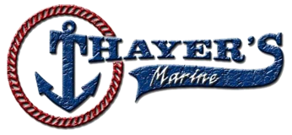 2025 CBN TOURNAMENT #1 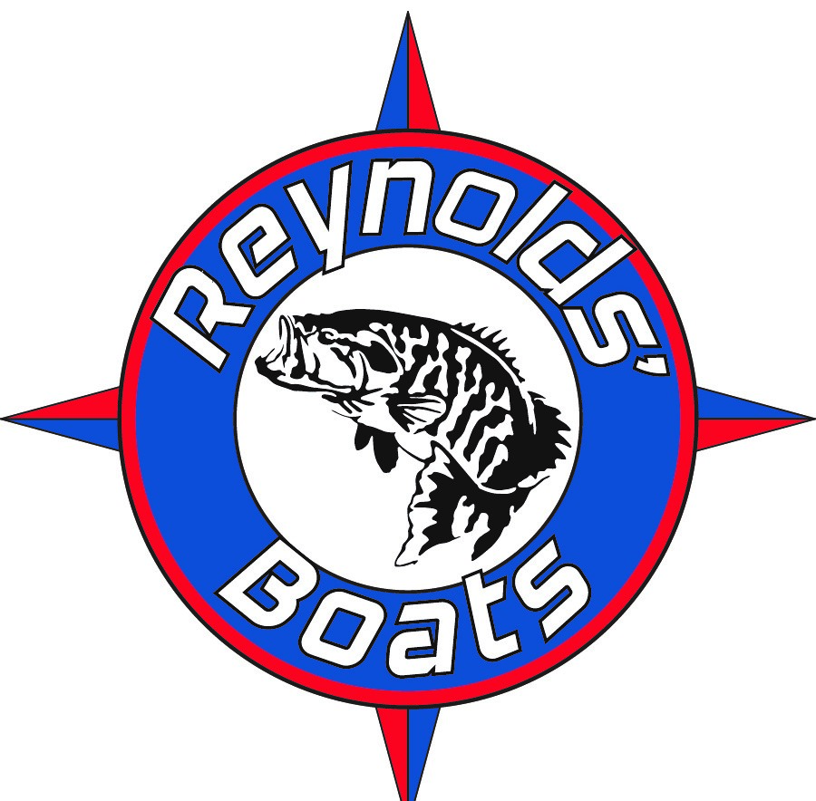

Candlewood Lake – Squantz Launch
SUNDAY, April 6th, 8AM TO 4PM

OPTIONAL $10.00 LUNKER, CASH AT THE RAMP!!!
Paired Anglers and Co-Anglers MUST contact each other prior to the event. If possible, arrange to meet prior to arriving at at launch. Please note the following ARRIVAL PROCEDURE:
All paired Boat Anglers and Co-Anglers that arrive at Squantz will be directed where to park. Please prepare your boat for launching and have your angler in the boat before proceeding to the ramp. Trailer runners will be at check in table for those anglers fishing alone. MUST BE IN THE WATER BY 7:30!!!!
Anglers being launched by a trailer runner need to pick their keys at check in table prior to tournament start.
ALL ANGLERS MUST REGISTER AT THE CHECK-IN TABLE PRIOR TO LAUNCHING. LIVEWELLS WILL BE CHECKED AS PART OF THE CHECK IN PROCES. ALL ANGLERS MUST FOLLOW THIS AGENDA AND THE CBN TOURNAMENT RULES. FAILURE TO DO SO MAY RESULT IN DISQUALIFICATION.
THE USE OF ALABAMA RIGS & PENETRATING CULL TAGS IS PROHIBITED.
NO GAS MOTORS UNTIL 7AM!
Please bring plenty of ice and take care of your fish to prevent stress.



Morning Start


Please be courteous to the tournament officials. There will be no separate flights in the morning. Proceed slowly in numerical order to checkout boat which will be positioned at the end of Squantz cove. Make sure your number is visible and live wells are open & running. Please pull your kill switch as you proceed past checkout boat. After your boat number has been acknowledged and live wells checked proceed at least 100 feet beyond the checkout boat prior to taking off. There is a 45 MPH speed limit which must be followed always. CO ANGLERS MUST FISH FROM THE BACK OF THE BOAT!
Any boating violations brought to the attention of the Tournament Committee WILL result in disqualification.
  LOWRANCE
Afternoon Check-In
Check in boat will be positioned at the no wake buoy at Squantz cove. Display your boat number to tournament officials and proceed to the launch area. When your boat number is called you may proceed to the weigh in area to the right of the ramp. All boat numbers are to be turned in at the scale even if you have no fish. Stay with your partner and please follow directions from the Tournament Committee staff. If possible, leave your biggest fish marked with a nonpenetrating cull tag.
Once you have finished weighing in, if you see that the Tournament Committee needs help and are able to do so, it would be greatly appreciated. With everyone’s cooperation the tournament should run smoothly. Not returning your boat # WILL result in disqualification.
ONLY OFFICIAL TOURNAMENT TRAIL BAGS WILL BE USED FOR WEIGH-IN. Five (5) FISH LIMIT. LENGTH – 12 INCHES 1 COURTESY MEASUREMENT ALLOWED (ANGLER MUST REQUEST)



FLIGHTS FOR CHECK-IN ARE AS FOLLOWS:
FLIGHT #1 | BOAT # 01 | THRU | # 14 | 3:30PM
FLIGHT #2 | BOAT # 15 | THRU | # 28 | 4:00PM


EMERGENCY NUMBERS
Vinny Mucci 203-525-4105 or Sylvia Morris – 203-675-4666

