

CBN Tournament # 3 Sunday, June 8th, 2025, 7am-4pm
CT River – Haddam Meadows State Park
  LOWRANCE

OPTIONAL LUNKER, $10.00, CASH AT THR RAMP!!!!!

Paired Anglers and Co-Anglers MUST contact each other prior to the event. If possible, arrange to meet before arrange to meet prior to arriving at Haddam Meadows.
Please note the following ARRIVAL PROCEDURE:

Please prepare boats for launching while lined up on the access road, (NOT AT THE CHECK IN TABLE) Boats will proceed along the access road to the launch area to register and be dropped into the water.
Trailer runners will take the vehicle keys to be kept on shore for the day. At the end of the day, once the Tournament Committee has weighed in & Volunteer Trailer Runners are available, they will start taking keys by boat # & bring trailers down to the launch. BE ALERT, WATCH FOR YOUR TRAILER & PLEASE BE PATIENT.

ALL ANGLERS MUST REGISTER AT THE CHECK-IN TABLE. LIVEWELLS WILL BE CHECKED AS PART OF THE CHECK IN PROCESS. ALL ANGLERS MUST FOLLOW THIS AGENDA AND THE CBN TOURNAMENT RULES. FAILURE TO DO SO MAY RESULT IN DISQUALIFICATION. Morning Start
Please be courteous to the tournament officials at all times. There will be no separate flights in the morning. ALL BOATS will stage SOUTH of the boat ramp and once called will SLOWLY proceed in numerical order past the dock where they will be checked by the Tournament Committee staff. Please make sure your number is visible and your livewells are open with pumps running. You will be asked to pull your kill switch, please keep a safe distance between boats. Once you are acknowledged, proceed beyond the No Wake Zone prior to taking off.
There is a 30 MPH speed limit which must be followed at all times. YOU MUST ABIDE ALL NO WAKES!!! Any boating violations brought to the attention of the Tournament Committee WILL result in disqualification.


 Afternoon Check-In 

The Check-In Boat will be by the no wake buoy south of the launch. YOU MUST CHECK IN!!! Display your boat # to the tournament officials and then watch for your trailer or drop your partner at the ramp to get your vehicle.

Contestants will be given a weigh in bag as they exit the ramp area. Once parked, bag your fish and immediately proceed to the weigh in area. Please follow directions from the Tournament Committee staff. If possible, leave your biggest fish marked with a cull tag.

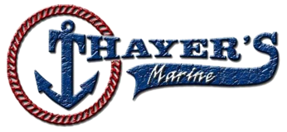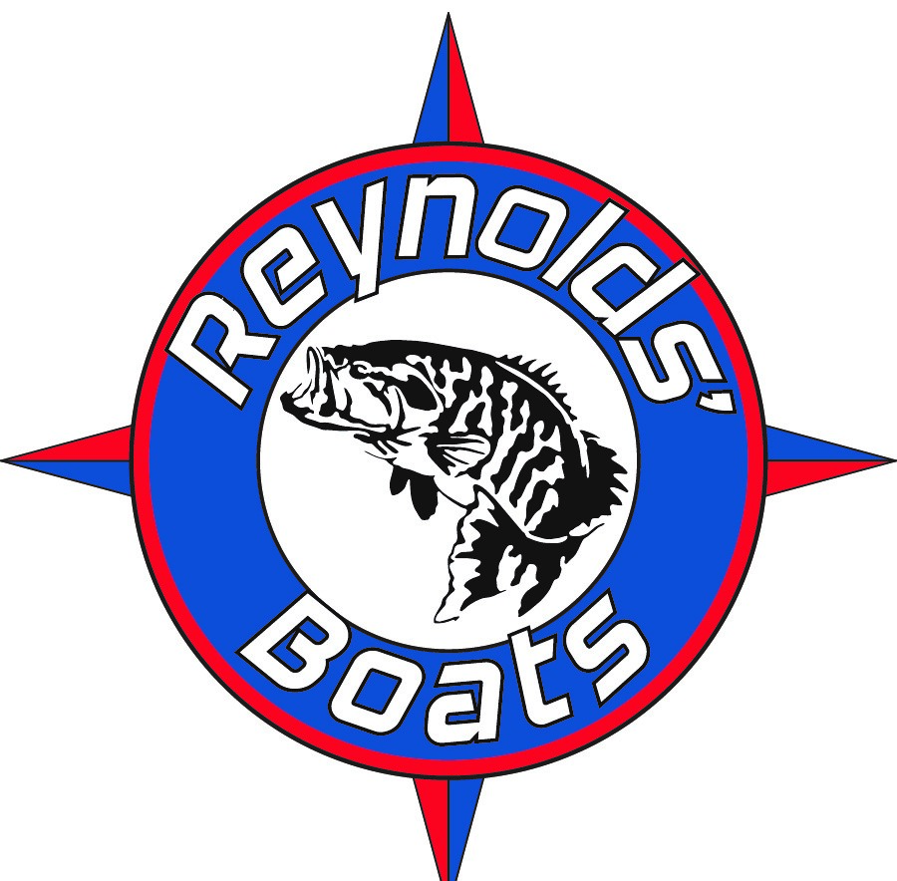

Not returning your boat # WILL result in disqualification.
ONLY OFFICIAL TOURNAMENT TRAIL BAGS WILL BE USED FOR WEIGH-IN. FIVE (5) FISH LIMIT. LENGTH – 12 INCHES 1 COURTESY MEASUREMENT ALLOWED (ANGLER MUST REQUEST)
FLIGHTS FOR CHECK-IN ARE AS FOLLOWS:
FLIGHT #1 | BOAT#1 | THRU | #13 | 3:30PM
FLIGHT #2 | BOAT#14 | THRU | #26 | 4:00PM

EMERGENCY CELL PHONE NUMBERS
Vinny Mucci 204-525-4105

